Objective:
Allow the user to modify the used quantity.

Short Description:
Currently the used quantity is updated when the user issue or return. We need to enable the user to modify the used quantity in the C/T or PO cost sheet, without having to go through the issue or return. Furthermore, the feature of modifying the used quantity should make the same updates in the stock. Taking into consideration the different types of material costing methods.

Long Description:
- Case of Average, Standard, LIFO, and FIFO Costing Methods:

When the user presses the Issue/Return button the screen in figure 1 will be displayed. We will add a new button called Edit Used.
Figure 1.
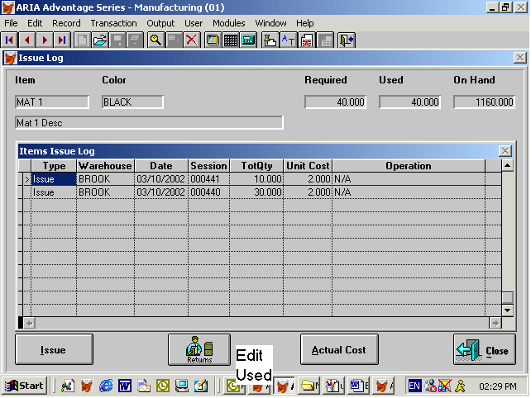

When the user presses the Edit Used button we will display a screen similar to the one that is displayed when the user presses the return button. Figure 2 will illustrate the screen that appears when the user presses the return button. We will make the following changes in the new screen:
- Return date will be date.
- Remove the Return quantity and put the return cost instead of it. The return cost will be editable if the amended used quantity is less than the issued only.
- We will enable the used quantity field. When the user amends the used quantity and it was less than the issued quantity, we will enable the return cost field. Then when pressing the OK button we will create a return transaction with the difference between the issued quantity and the amended used quantity, and when the issued is less than the amended used quantity, then we will create an issue transaction.
Figure 2
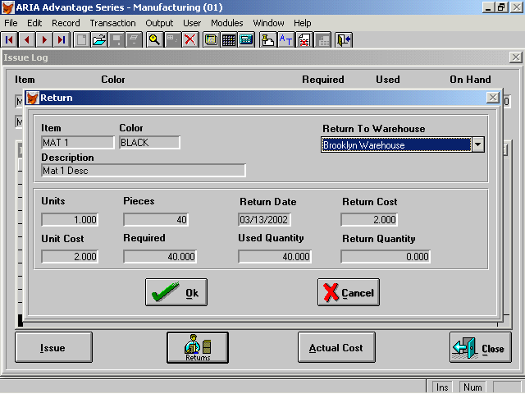
- Case of Lot Costing Method:
When the user presses the Issue/Return button the screen in figure 3 will be displayed. We will add a new button called Edit Used.
Figure 3.
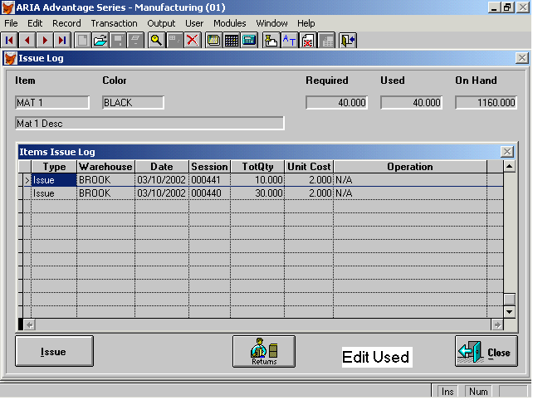

When the user presses the Edit Used button we will display a screen similar to the one that is displayed when the user presses the return button. Figure 4 will illustrate the screen that appears when the user presses the return button. We will make the following changes in the new screen:
- Return date will be date.
- Remove the Return quantity and return cost (since the user will select a lot #. Suggestion.). We will enable the used quantity field. When the user amends the used quantity, we will check if the quantity is less than the issued (we can display a notification message to inform the user with the quantity that will be returned) then we will display all the issued lots in order to allow the user to select the lot that we will return the quantity to. If the used quantity is greater than the issued, then we will display all the lots in order to issue from (we can display a notification message to inform the user with the quantity that will be issued). We will check if selected lot has available quantity or not. Figure 5 will illustrate the screen that will consist of the available lots.
Figure 4
Figure 5
